Using a ‘master copy’ I created my own Virtual Machine by cloning the entire copy.

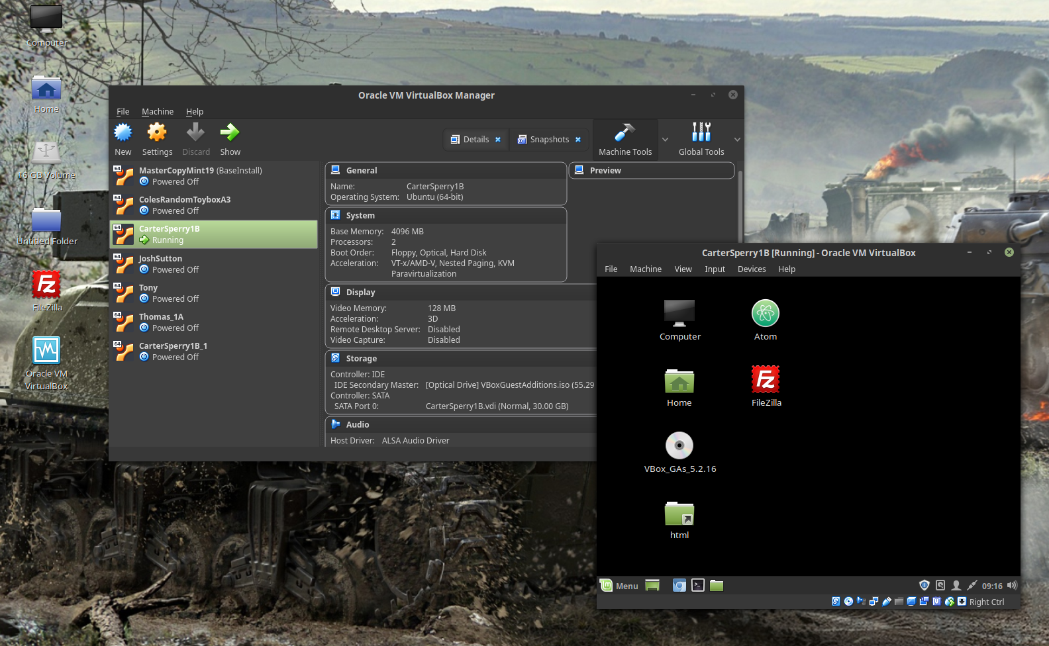

In order to preserve my Virtual Machine in case of computer reimaging or other students deleting my VM I created an off site backup using a flash drive.

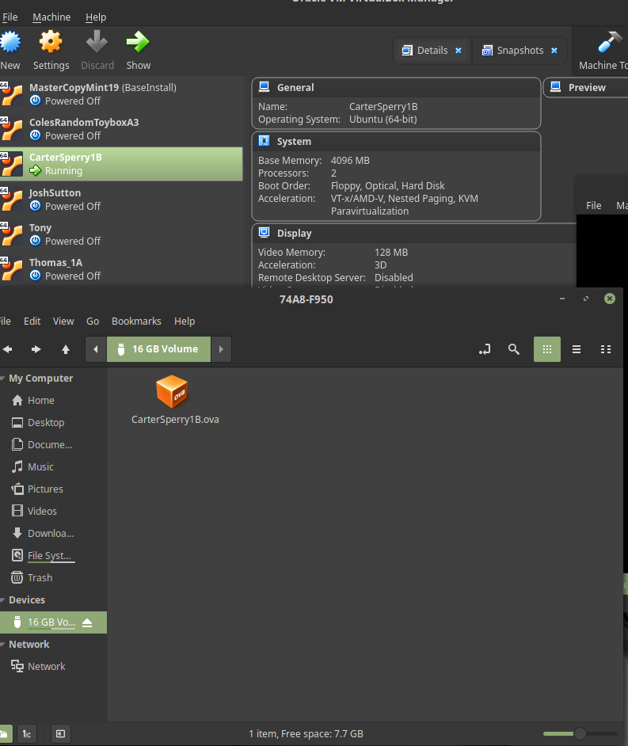

As another layer of security I took a screenshot of my machine so if any software downloads or updates break something, I have a quick and efficient way to get my machine working again.

